Console Add Item – eBay API/SDK Tutorial for VB.Net

This tutorial shows the bare minimum to create a new listing on eBay site using eBay SDK/API. You can find the code used in this tutorial in the Samples/VB.NET/ConsoleAddItem folder of the .NetSDK package.

Prerequisite:
1. eBay Trading SDK for .Net 2.0
2. An eBay user token
3. Visual Studio 2005 (or 2008)

Steps to Create the Console Add Item Sample:
1. Create a new Visual Basic Console Application called ConsoleAddItem in Visual Studio (see Fig 1).
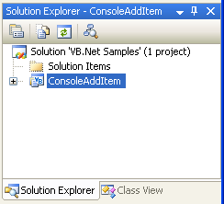

Fig 1. ConsoleAddItem Project

2. Add a new application configuration file (App.config, see Fig. 2) to this project. This file will contain some configuration information such as your eBay user token and the API Server Url, that are necessary for calling the eBay API (see Listing 1). Please update the token value with your own token before you run this sample.

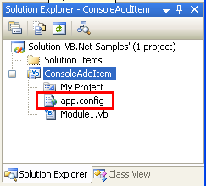

Fig 2. Application configuration file

<?xml version="1.0" encoding="utf-8" ?>
<configuration>
<appSettings>
<!-- API Server URL, required -->
<!-- For production site use: https://api.ebay.com/wsapi -->
<!-- For Sandbox site use: https://api.sandbox.ebay.com/wsapi -->
<add key="Environment.ApiServerUrl" value="https://api.sandbox.ebay.com/wsapi"/>
<!-- User token for API server access (required) -->
<add key="UserAccount.ApiToken" value="your ebay user token"/>
</appSettings>
</configuration>

Listing 1. Content of App.config

3. Add a reference to the eBay.Service assembly (see Fig 3). You will find the assembly in the root folder of your eBay SDK for .Net installation. eBay.Service assembly is the main component of the SDK, and it encapsulates eBay API calls and hides the low-level communication details from you. Make sure you also add a reference to the System.configuration .Net assembly.

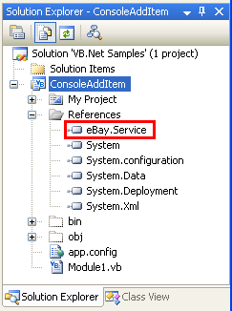

Fig 3. eBay.Service assembly

4. In the main Module file (see Fig 4), import the following .Net namespaces and SDK namespaces so you can have reference to calls and classes in the SDK (see Listing 2). Provide the module name and the variable definition at the same time.

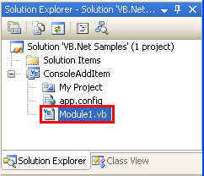

Fig 4. The Main Module File

Imports System.Configuration
Imports eBay.Service.Call
Imports eBay.Service.Core.Sdk
Imports eBay.Service.Core.Soap
Imports eBay.Service.Util

Module Module1

Private apiContext As ApiContext = Nothing

Listing 2. Import Namespace

5. In order to call the eBay API, first you need to initialize an ApiContext object. ApiContext object contains all the configurations and settings that are necessary for calling the eBay API.

In the main Module file, create a function called GetApiContext (see Listing 3). In this function, we populate the ApiContext object with your user token and the API server Url found in the App.config file. We also set Site on the ApiContext object to target the eBay U.S. site.

You can configure the ApiContext object to log all of the communication to a logger (for example, a text file). Here, we’re going to log all the SOAP messages to a text file. If anything goes wrong, logging is extremely helpful for troubleshooting.

''' <summary>
''' Populate eBay SDK ApiContext instance with data from application configuration file
''' </summary>
''' <returns>ApiContext instance</returns>
''' <remarks></remarks>
Private Function GetApiContext() As ApiContext

'apiContext is a singleton
'to avoid duplicate configuration reading
If (apiContext IsNot Nothing) Then
Return apiContext
Else
apiContext = New ApiContext

'set Api Server Url
apiContext.SoapApiServerUrl = _
ConfigurationManager.AppSettings.Get("Environment.ApiServerUrl")
'set Api Token to access eBay Api Server
Dim apiCredential As ApiCredential = New ApiCredential
apiCredential.eBayToken = _
ConfigurationManager.AppSettings.Get("UserAccount.ApiToken")
apiContext.ApiCredential = apiCredential
'set eBay Site target to US
apiContext.Site = SiteCodeType.US

'set Api logging
apiContext.ApiLogManager = New ApiLogManager
Dim fileLogger As FileLogger = New FileLogger("listing_log.txt", True, True, True)
apiContext.ApiLogManager.ApiLoggerList.Add(fileLogger)

Return apiContext

End If

End Function

Listing 3. GetApiContext function

6.
In order to list an item on eBay, first you need to create a new instance of the ItemType class.

In the main Module file, create a function called BuildItem (see Listing 4). In this function, we populate the item with information such as item title and description, listing category, payment methods and shipping details, etc. For a detailed discussion about what information you should provide to list an item, please refer to the eBay Trading API documentation.

''' <summary>
''' Build a sample item
''' </summary>
''' <returns>ItemType instance</returns>
Private Function BuildItem() As ItemType
Dim item As ItemType = New ItemType()

' item title
item.Title = "Test Item"
' item description
item.Description = "eBay SDK sample test item"

' listing type
item.ListingType = ListingTypeCodeType.Chinese
' listing price
item.Currency = CurrencyCodeType.USD
item.StartPrice = New AmountType()
item.StartPrice.Value = 20
item.StartPrice.currencyID = CurrencyCodeType.USD

' listing duration
item.ListingDuration = "Days_3"

' item location and country
item.Location = "San Jose"
item.Country = CountryCodeType.US

' listing category , Photography Software
Dim category As CategoryType = New CategoryType()
category.CategoryID = "30022"
item.PrimaryCategory = category

' item quality
item.Quantity = 1

' payment methods
item.PaymentMethods = New BuyerPaymentMethodCodeTypeCollection()
item.PaymentMethods.Add(BuyerPaymentMethodCodeType.PayPal)
' email is required if paypal is used as payment method
item.PayPalEmailAddress = me@ebay.com

' item condition, New
item.ConditionID = 1000

' handling time is required
item.DispatchTimeMax = 1

' shipping details
item.ShippingDetails = BuildShippingDetails()

' return policy
item.ReturnPolicy = New ReturnPolicyType()
item.ReturnPolicy.ReturnsAcceptedOption = "ReturnsAccepted"

Return item

End Function

Listing 4. BuildItem function

7. In the main Module file, create a helper function called BuildShippingDetails (see Listing 5). This function is used by the BuildItem function to build sample shipping details.

''' <summary>
''' Build sample shipping details
''' </summary>
''' <returns>ShippingDetailsType instance</returns>
Private Function BuildShippingDetails() As ShippingDetailsType
' Shipping details
Dim sd As ShippingDetailsType = New ShippingDetailsType()

sd.ApplyShippingDiscount = True
Dim amount As AmountType = New AmountType()
amount.Value = 2.8
amount.currencyID = CurrencyCodeType.USD
sd.PaymentInstructions = "eBay .Net SDK test instruction."

' Shipping type and shipping service options
sd.ShippingType = ShippingTypeCodeType.Flat
Dim shippingOptions As ShippingServiceOptionsType = New ShippingServiceOptionsType()
shippingOptions.ShippingService = _
ShippingServiceCodeType.ShippingMethodStandard.ToString()
amount = New AmountType()
amount.Value = 2.0
amount.currencyID = CurrencyCodeType.USD
shippingOptions.ShippingServiceAdditionalCost = amount
amount = New AmountType()
amount.Value = 10
amount.currencyID = CurrencyCodeType.USD
shippingOptions.ShippingServiceCost = amount
shippingOptions.ShippingServicePriority = 1
amount = New AmountType()
amount.Value = 1.0
amount.currencyID = CurrencyCodeType.USD
shippingOptions.ShippingInsuranceCost = amount

sd.ShippingServiceOptions = New ShippingServiceOptionsTypeCollection()
sd.ShippingServiceOptions.Add(shippingOptions)

Return sd

End Function

Listing 5. BuildShippingDetails function

8. Now that all building blocks are ready, let’s wire them together in the Main function (see Listing 6). The overall call flow is shown in Fig 5:

Sub Main()

Try
Console.WriteLine("+++++++++++++++++++++++++++++++++++++++")
Console.WriteLine("+ Welcome to eBay SDK for .Net Sample +")
Console.WriteLine("+ - ConsoleAddItem +")
Console.WriteLine("+++++++++++++++++++++++++++++++++++++++")

'[Step 1] Initialize eBay ApiContext object
Dim apiContext As ApiContext = GetApiContext()

'[Step 2] Create a new ItemType object
Dim item As ItemType = BuildItem()

'[Step 3] Create Call object and execute the Call
Dim apiCall As AddItemCall = New AddItemCall(apiContext)
Console.WriteLine("Begin to call eBay API, please wait ...")
Dim fees As FeeTypeCollection = apiCall.AddItem(item)
Console.WriteLine("End to call eBay API, show call result ...")
Console.WriteLine()

'[Step 4] Handle the result returned
Console.WriteLine("The item was listed successfully!")
Dim listingFee As Double = 0.0
Dim fee As FeeType
For Each fee In fees
If (fee.Name = "ListingFee") Then
listingFee = fee.Fee.Value
End If
Next
Console.WriteLine(String.Format("Listing fee is: {0}", listingFee))
Console.WriteLine(String.Format("Listed Item ID: {0}", item.ItemID))

Catch ex As Exception
Console.WriteLine("Fail to list the item : " + ex.Message)
End Try

Console.WriteLine()
Console.WriteLine("Press any key to close the program.")
Console.ReadKey()

End Sub

Listing 6. the Main function

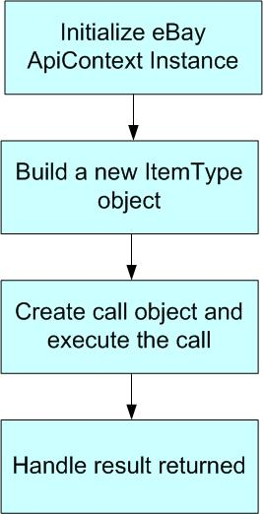

Fig 5. The Call Flow

After the ItemType instance is created, we call the AddItem API and pass in the newly created ItemType instance as a parameter. If the call is successful, a FeeTypeCollection class instance will be returned. This collection instance contains all of the individual fees resulting from the item listing. Lastly, we output the Listing fee and Listed Item ID in the console (for your application you can handle the response according to your own requirements). The main function also shows the basic exception handling. If anything goes wrong, you are responsible for catching and handling exceptions accordingly.

9. Debug the ConsoleAddItem project in Visual Studio. You will see the following output in the console window (see Fig 6.). If anything goes wrong, you can check the log file in the bin\Debug folder for troubleshooting:

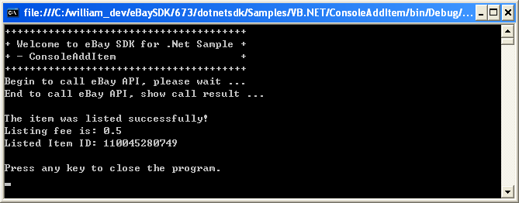
Fig 6. Console Output

10. If the listing is successful, you can verify the item by searching the item ID in the eBay sandbox (or production if you configured production API server Url in the application configuration file) (see Fig 7).

Now you have a working sample which can list item to eBay site using eBay SDK. Congratulations!

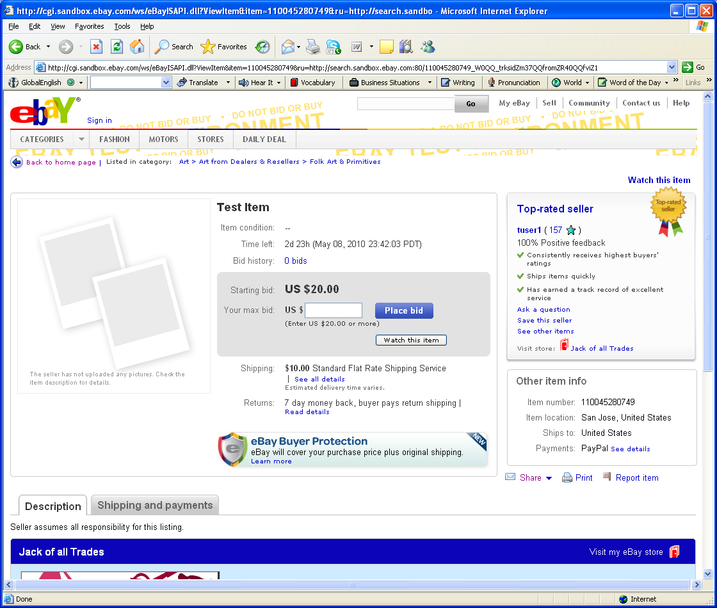
Fig 7. Live Item on eBay Site

